# **Project Report Template**

1. Introduction

1.1Overview

This project describes the different countries economic freedom score in 2022. And we are also analyzing the top 40 ranking countries in the index , bottom ranking countries by index , index score based on unemployment rate , financial freedom , population , index score based on 5 year GDP rate in percentage , inflation rate in different countries , correlation between inflation & unemployment , GDP & monetary freedom , top 40 countries by GDP growth rate .The analysis are demonstrated using maps , bar charts , pie charts , etc.

An index of economic freedom measures and ranks countries according to relevant standard judged by the creators of the index. Indices of economic freedom consider free-market economies at the high-end of the spectrum for analysis. There is a firm correlation between both the earnings a country's citizens enjoy and the index of economic freedom ranking of such country. Investors can use the index of economic freedom as a faster way to observe the changes in economies.

An index of economic freedom compares the jurisdictions against each other for various aspects, such as trade , freedom, judicial effectiveness, and tax burden. These factors may be weighed for their influence on economic freedom and collated into a single score for ranking. The economic freedom can be measured by business freedom , trade , monetary freedom , investment , financial , property rights , labor etc.

1.2Purpose

By this project we are able to understand the economic growth of different countries .During analyzing we can able to know the growth of countries from the past year by using this we can improve our countries economic growth .The following are the uses of index of economic freedom:

* The Index provides valuable data for measuring the results of government policies and programs.
* The Index is a helpful guide for anyone interested in seeing which policies are succeeding in promoting economic freedom.
* The Index provides objective background material on nearly every economy in the world.

1. *Problem Definition & Design Thinking*

* 1. Empathy Map

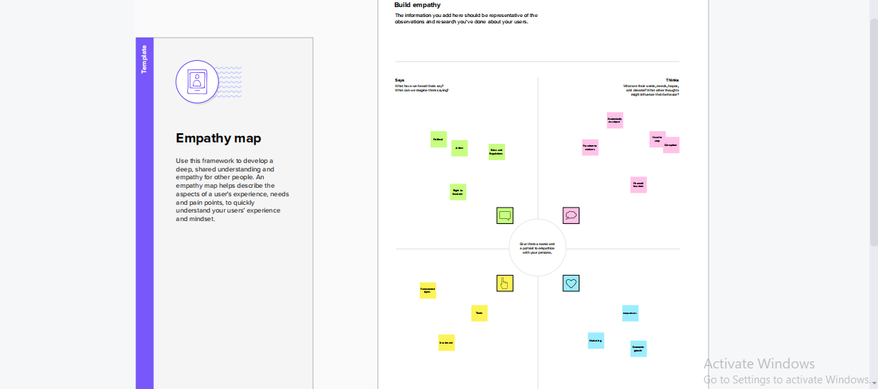

* 1. Ideation and Brainstorming Map

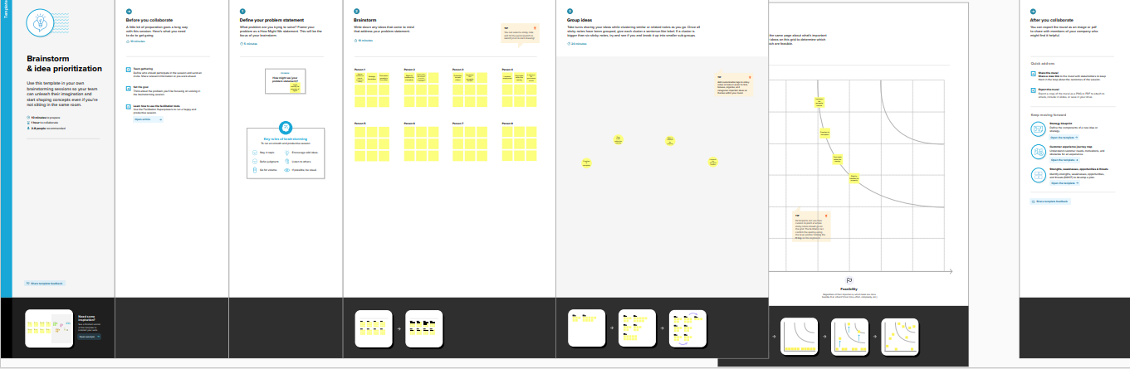

1. *RESULT*

*Dashboard 1*

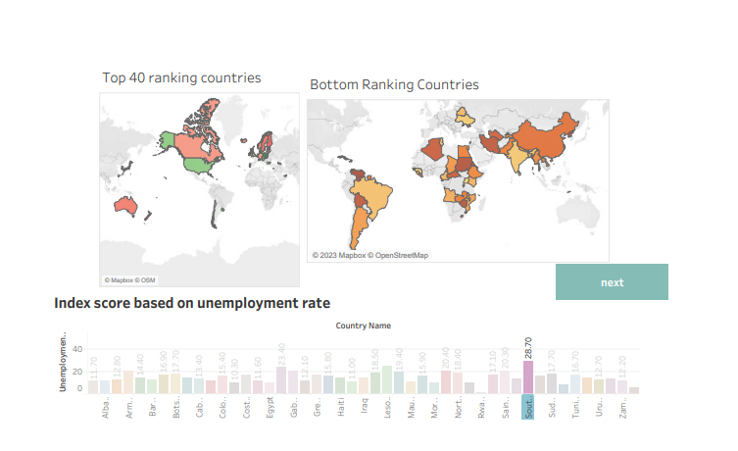

*Dashboard 2*

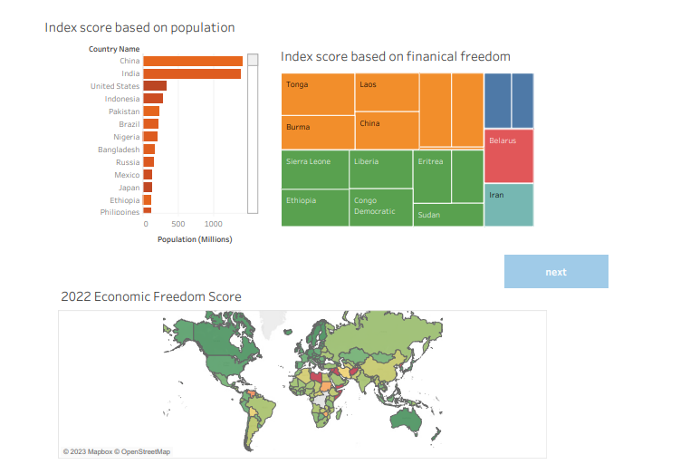

*Dashboard 3*

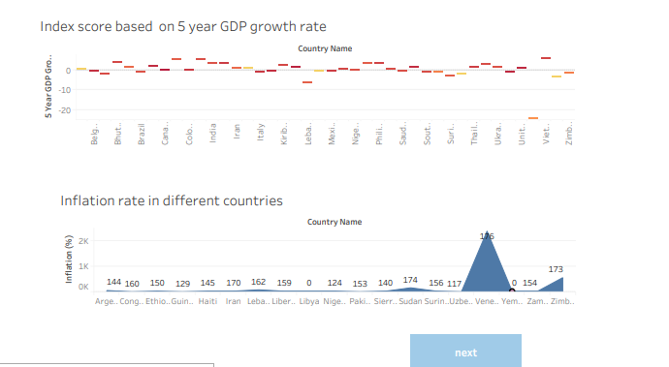

*Story*

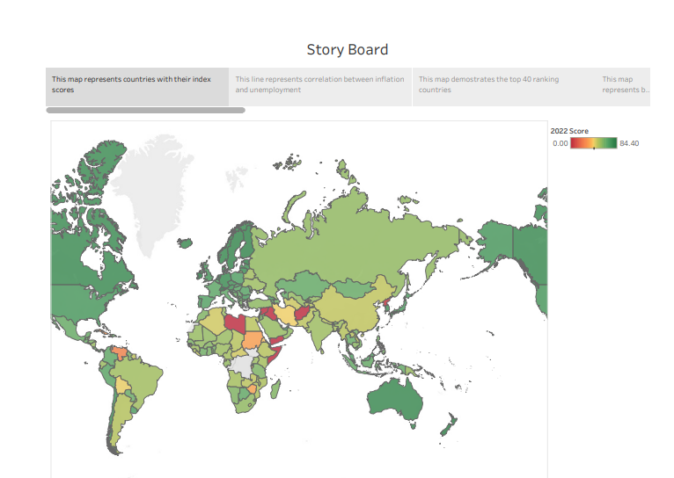

*Web Integration*

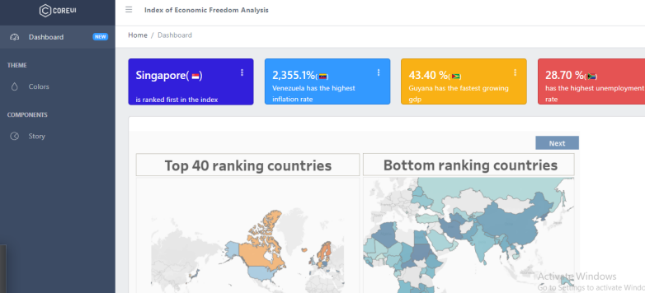

*4. Advantages & Disadvantages*

Advantages

* While plotting map , charts it is easy to identify the index score.
* It helps others to easily understand the topic while plotting graphs , maps etc..

Disadvantages

* It is risk to identify the countries score easily.
* In maps it is difficult to identify the index scores of the countries.

1. *Applications*

This data analysis can be applied in the field of government agencies to identify the economic growth of different countries all over the world. It can be demonstrated empirically the societies that adopted certain traits are more prosperity to the country.

1. *Conclusion*

In this data analysis project the dataset which has given to our project is index score in 2022 .In the index score 183 countries economic growth , their world rank , region rank , tax burden , fiscal health , labor freedom , GDP growth rate , unemployment & inflation(%) etc , are given . Using these data’s the countries data visualization is created. Data visualization is the process to analyse the index of economic freedom include bar charts , line charts , heat maps , scatter plots , pie charts , maps and so on. These visualizations can be used to compare performance , track changes over time , show distribution and relation between variables.

The data are published in the tableau public software to communicate results and progress. This publisher helps to communicate their performance to others.

1. *Future Scope*

There is no enhancement to be made in the future for building this data analytic.